FCMG School 2017 – Geomechnics 101 Schedule

Time | Program
7:30-8:30am | Breakfast
8:30-8:40am | Intro to the course - Guimarães and Grasselli (10 min)
8:40-10:00am | Geomechanics fundamentals: The continuum - Guimarães (80 min)
10:15-10:20am | Break (20 min)
10:20-12:00pm | Geomechanics fundamentals: The fractures - Grasselli (80 min)
12:00-1:00pm | Lunch
1:00-2:50pm | Geomechanics fundamentals: Continnum modelling - Guimarães (110 min)
2:50-3:10pm | Break (20 min)
3:10-5:00pm | Geomechanics fundamentals: Discontinnum modelling - Grasselli (110 min)

FCMG School 2017 Instructors Bio

Dr. Leonardo Guimarães
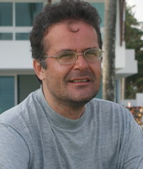 | Leonardo Guimarães is a faculty member of Civil Engineering Department at UFPE, Recife, Brazil. He is holder of the Industrial Research Chair in Reservoir Simulation of the Foundation CMG in the area of “Multi-physics Analysis, Optimization, and Uncertainty Propagation Applied to Reservoir Engineering”. Professor Leonardo is principal investigator and consultant of research projects on analysis of geomechanical and geochemical integrity of reservoir and cap rocks. He is also frequent reviewer for top journals and research proposals in the field of coupled Thermo-Hydro-Mechanical and Geochemical problems in porous media.

Dr. Giovanni Grasselli
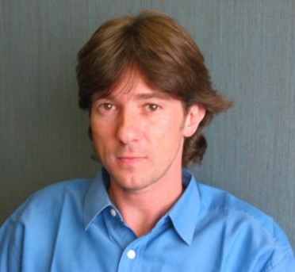 | Giovanni Grasselli is Professor and NSERC/Foundation CMG Research Chair in Fundamental Petroleum Rock Physics and Rock Mechanics at the University of Toronto. His research focuses on hybrid finite-discrete element (FDEM) numerical technology, experimental visualization techniques and geomechanics principles applied to the study of tunneling and hydraulic fracturing. He received the prestigious ISRM Rocha Medal (2004) for best thesis worldwide in rock mechanics and supervised two Rocha Medal winner (2015 and 2017). Through the start-up company Geomechanica Inc., the FDEM technology is currently commercialized and translated to engineering practice.

